Modular Robotics: Molucube

Cole Butler

Ali Helmi

Andrew Hunt

Carlos Torres

**Concept of Operations**

REVISION – 1

3 October 2022

Concept of Operations

for

Modular Robotics: Molucube

Team <10 >

Approved by:

_____________________________

Project Leader Date

_____________________________

Prof. Kalafatis Date

_____________________________

T/A Date

**Change Record**

|  |  |  |  |  |
| --- | --- | --- | --- | --- |
| **Rev.** | **Date** | **Originator** | **Approvals** | **Description** |
| **-** | 09/15/2022 | Carlos Torres |  | Draft Release |
| **1** | 10/03/2022 | Andrew Hunt |  | Revisions 1 |

Table of Contents

Table of Contents III

List of Tables IV

No table of figures entries found. Error! Bookmark not defined.

List of Figures V

1. Executive Summary 1

2. Introduction 2

2.1. Background 2

2.2. Overview 2

2.3. Referenced Documents and Standards 3

3. Operating Concept 4

3.1. Scope 4

3.2. Operational Description and Constraints 4

3.3. System Description 4

3.4. Modes of Operations 4

3.5. Users 5

3.6. Support 5

4. Scenario(s) 6

4.1. Pick and Place Objects 6

5. Analysis 6

5.1. Summary of Proposed Improvements 6

5.2. Disadvantages and Limitations 6

5.3. Alternatives 6

5.4. Impact 7

List of Tables

No table of figures entries found.

List of Figures

Figure 1 Modular Robotics Block Diagram 1

# Executive Summary

Our goal for this project is to create a series of modules that can be combined into a manually configurable, modular robot capable of performing a user defined task. We specifically aim to create a system that is simpler and less expensive than alternative, autonomously reconfigurable designs. Our modular robot system will have modules that are each designed to perform a specific function as a part of the whole robot and can easily be swapped with other modules as well as be reconfigured by the user to perform new tasks. Each module will rely on a central controller module that will gather information from the other modules, as well as tell each module what to do. This will concentrate the most complex tasks in one module, which will allow us to meet our goal of making the other modules simpler and cheaper. A central controller module will also make it easy to configure the robot, as every other module will be set up to accept commands from the central module.

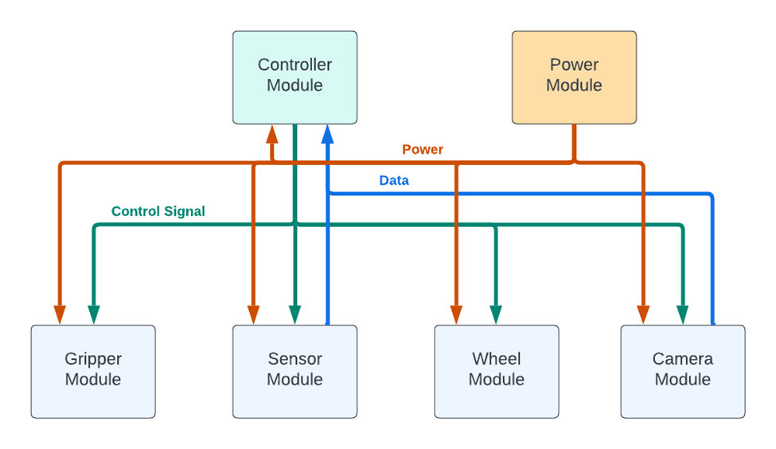

Figure 1 Modular Robotics Block Diagram

# Introduction

The purpose of this document is to introduce a modularized robot that is designed and constructed in unique ways presented in the following sections. The goal of this project is to be able to build a configurable modular robot that is capable of accomplishing specific tasks programmed to it, while also minimizing the drawbacks of other designs. Our modular robot utilizes different types of modules connected together while each module carries a job in order to achieve the task specified.

## Background

In this report, we would like to introduce robots which are machines made to carry and execute specific tasks with little to no human intervention. Various advancements have been made in the robotics field that includes but are not limited to automation, self-learning, self-reproduction, and many other. Every single type of advancement is backed by extensive research, and the one type we intend to potentially contribute to is modularizing.

Modular robotics is a newly introduced field that is receiving popularity, and its purpose is to modularize components of a robot in a way that makes the robot reconfigurable. Modules utilizing universal connection across the network unlock the ability which allows it to repurpose and achieve lots of different functionalities without the need to be completely redesigned and rebuilt. Many studies have been conducted in the field of modular robotics, and our research discovered many interesting applications and previous works, such as “Molecubes” which is a project done by a team from Cornell University. They produced a successful modular robot that is built from cubic modules which they referred to as “Molecubes” [1]. They presented the hardware and the software of their creation where there is an outline of their roadmap leading up to their final product. Cornell University Team’s innovative approach was the diagonal rotation of each module, as explained in the article, which allows three printed circuit boards (PCBs) to be connected at all times. However, this approach adds to the complexity of constructing the modules, addition to having every module capable of all tasks is not only complex but redundant and expensive. Our goal is to minimize those drawbacks and achieve simplicity for the user to be able to build our modules with ease.

Another team from Switzerland proposed the idea of reconfigurable furniture which as implied utilizes the concept of modular robotics making the furniture smart and situationally changeable [2]. A work published in Nature Magazine took modular robotics to a whole different level, where they referenced biological organisms’ self-reproductions [3]. Thus, introduced the idea of a modular robot capable of self-reproducing that consists of identical cubic modules and universal connectors. Allowing every module to think for itself and communicate with the other modules to accomplish a certain task cooperatively. A study done by Hossein Ahmadzadeh and his peers, published by J Intell Robot Systems, lists most of the contributions toward modularizing robots ordered by their characteristics [4]. All these projects are innovative, however, they go against the goal we are trying to accomplish with our modular robot.

## Overview

The overview of our project is that we are aiming to construct a modular robot built from different generic types of modules, ideally similar in size but containing identical universal connectors. We plan to achieve a few things that include price reduction and simplification while still having the robot accomplish the intended tasks and behaviors specified by the user. Our project consists of various steps and different subsystems integrated thereby realizing our modular robot. The project’s design and intended functionality are explained in detail in the following sections of this document. Briefly, the robot consists of six different types of modules that can be configured and connected in any way of the user’s choice. Those modules are the camera module, controller module, wheel module, power module, ultrasonic sensor module, and gripper arm module. We are going for a rover-like robot as an illustration of the capabilities of our design, and our robot is going to be tested on the performance of executing programmed tasks. The flow of data from the camera module and the sensor module which provide the navigation information to the controller module. Using the information provided, the controller module will decide where the robot will go accordingly by sending signals to the wheel modules. And if the intended object was identified then the controller module signals the gripper arm module to pick it up and then drop it in the designated area.

## Referenced Documents and Standards

1. Molecubes Extended: Diversifying Capabilities of Open-Source Modular Robotics, Cornell University.
2. Roombots—Modular Robots for Adaptive Furniture, Switzerland.
3. Self-reproducing machines, Nature Magazine.
4. Modular Robotic Systems: Characteristics and Applications, J Intell Robot Syst (2016).
5. A low cost, modular robotics tool carrier for precision agriculture research.

# Operating Concept

## Scope

Modular robots, referred to as “molecubes”, aim to decrease the cost for robot design and maintenance by dividing functions up between separate modules. Conventional robots lack flexibility and are difficult to integrate with new hardware as they are self-contained and designed for a specific purpose. By allotting functions to separate modules, these modules can be combined into various robots while simultaneously making each part easily replaceable.

## Operational Description and Constraints

The proposed molecubes are intended to be used for creating a robot for almost any task simply by connecting the necessary modules. One robot instance could include a controller, camera, gripper, motors, and battery modules.

Requirements are as follows:

* Must operate autonomously, and be programmable for different tasks and configurations
* Modules must be able to connect to other modules and stay together during operation
* Modules must be designed to be relatively inexpensive and easily replaceable

## System Description

* Raspberry Pi/Microcontrollers: The Raspberry Pi will be used to control and communicate with every module connected to a robot via serial communication and will be implemented in the controller module. It will be programmable for different tasks. Microcontrollers will be implemented to help communication between modules and the Raspberry Pi.
* Power Delivery: The power delivery will be implemented into the power module for delivering power to all other modules. It will consist of a battery management system for two LiPo batteries in parallel, and power converters for providing all components with correct voltages.
* PCBs/Housing: Each module performs a different task and will house different parts (motors or a camera). For that reason, each module will require a PCB specific to these parts. The housing will be a box used for containing the parts of each module, as well as providing connections on each face where necessary. These connections are for each module to be fastened together as well as communicate with each other.
* Computer Vision/Robot Arm: The Computer Vision subsystem will primarily make use of camera and sensor modules to allow a robot to make sense of its surroundings. The robot arm will allow a robot to lift and manipulate objects in its vicinity. It will be a simple arm consisting of three joints (shoulder, elbow, wrist) and a gripper.

## Modes of Operations

A modular robot will be capable of operating in several manners defined by the user and the connected modules. It will operate autonomously to perform these defined tasks.

## Users

A modular robot made up of these separate modules has the potential for surveillance environments with unknown conditions due to the low cost and modules being easily replaceable. This will be intended for users with a general knowledge of robotics due to the requirement of the robot being autonomous and programmable.

## Support

Support will come in the form of a detailed instruction manual noting information for each module, use cases, and connections. Short tutorials will be included to give the user step-by-step guidance on creating a simple modular robot from a microcontroller, battery, and sensor module, as well as how to program and control it. These tutorials will grow in complexity as more modules are included.

# Scenario(s)

## Pick and Place Objects

The main scenario for our robot is to demonstrate the interoperability of our various modules to navigate a marked course to grab specific ping pong balls and transport them to a basket. Our robot will use the camera module and computer vision to autonomously navigate through a marked course as well as identify specific ping pong balls. The motor and wheel modules will propel the robot through the course. The gripper arm module will be used to grab the specified ping pong balls and place them in a basket.

# Analysis

## Summary of Proposed Improvements

* Modular, multiple parts(cubes) on a robot can be moved around and attached somewhere else and still perform the task at hand. So for example if you have a car, a car has 4 wheels, say the two passenger side wheels come off. The car can no longer drive. So move the rear driver wheel to the passenger side rear and now the car can semi drive. It is not optimal but it can still drive. Our wheel modules can be replaced and swapped around no problem.
* Cost effective, since all parts(cubes) are the same and interchangeable, though less complex than the dedicated robot hence cheaper. Current task dedicated robots are more expensive.
* Interchangeable, multiple parts(cubes) can be moved to another place on the robot and still perform the desired function. As opposed to a dedicated robot where you can not move parts around, it only works where it currently is placed.
* Improved fault tolerance, since parts(cubes) can be moved around and still function just fine, having a fault wouldn't be hard to figure out. Simple disconnect and retest each cube.

## Disadvantages and Limitations

* Camera works best in lit conditions so if robot is in darkness then camera could have trouble detecting objects
* Lack of autonomy, Without autonomy, rigidity and non-back-drivability in coupling, large reconfigurable assemblies are not possible, and modular robots will remain vulnerable to the constraints of a real-terrain, where the ruggedness of an unstructured topology represents a major challenge for reliable mobility and maneuverability in practical applications.
* Maybe won’t be the absolute best at every task as opposed to a dedicated non modular robot that’s specifically designed for that task

## Alternatives

This project has budding research in robotics that tries to optimize the price and scalability. Custom-made robots can be made specific to a task, but that will come at a cost.

Could have army of dedicated robots but this is costly and takes up more space to house these robots

## Impact

Scalability, modularity, fault tolerance, interchangeability, cost-effectiveness, and ease of use.

Through using this modular robot, it would decrease the overall scale of the modules and even increase the overall size of the entire robot depending on how many are connected together so there is no one set size. So to save one's life by decreasing its size to fit in hard to reach human places would prove worth. The fact that the modules/cubes would be interchangeable would make fault tolerance high thus lessening the time to troubleshoot and ease of use. This would first aim to impact rural/unstructured areas as modular robots have not developed that kind of level of rigidity to wide variety or let alone treacherous terrain.